**General Appendix:**

<https://www.hays.com.sg/salary-guide/index.htm>

<http://time.com/money/2792145/the-right-amount-to-donate-to-charity/>

**Appendix A:**

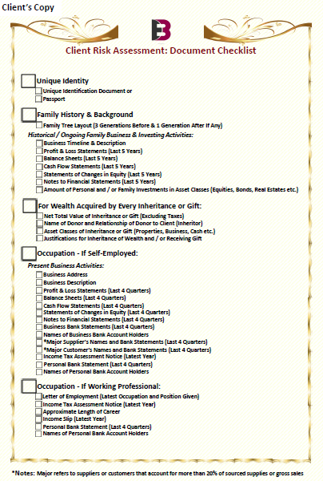

**Appendix B:**

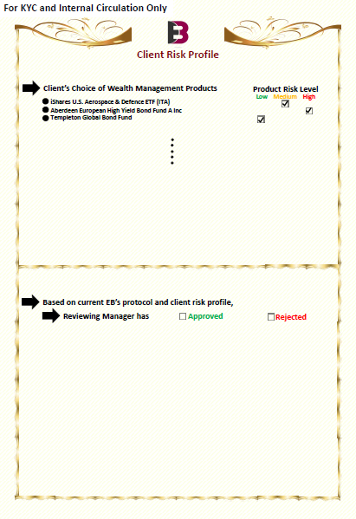

**Appendix C**

**Graphical demonstration of the Clientele Portal Prototype 1.0**

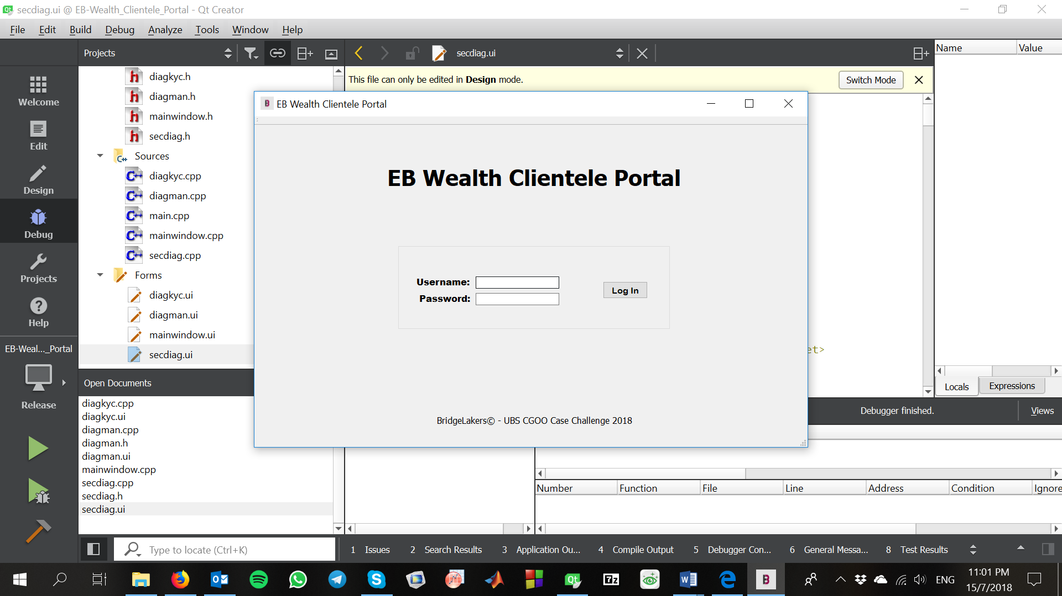

Figure 1. Login page.

CA – username: ca password: ca

KYC – username: kyc password: kyc

Manager – username: man password: man

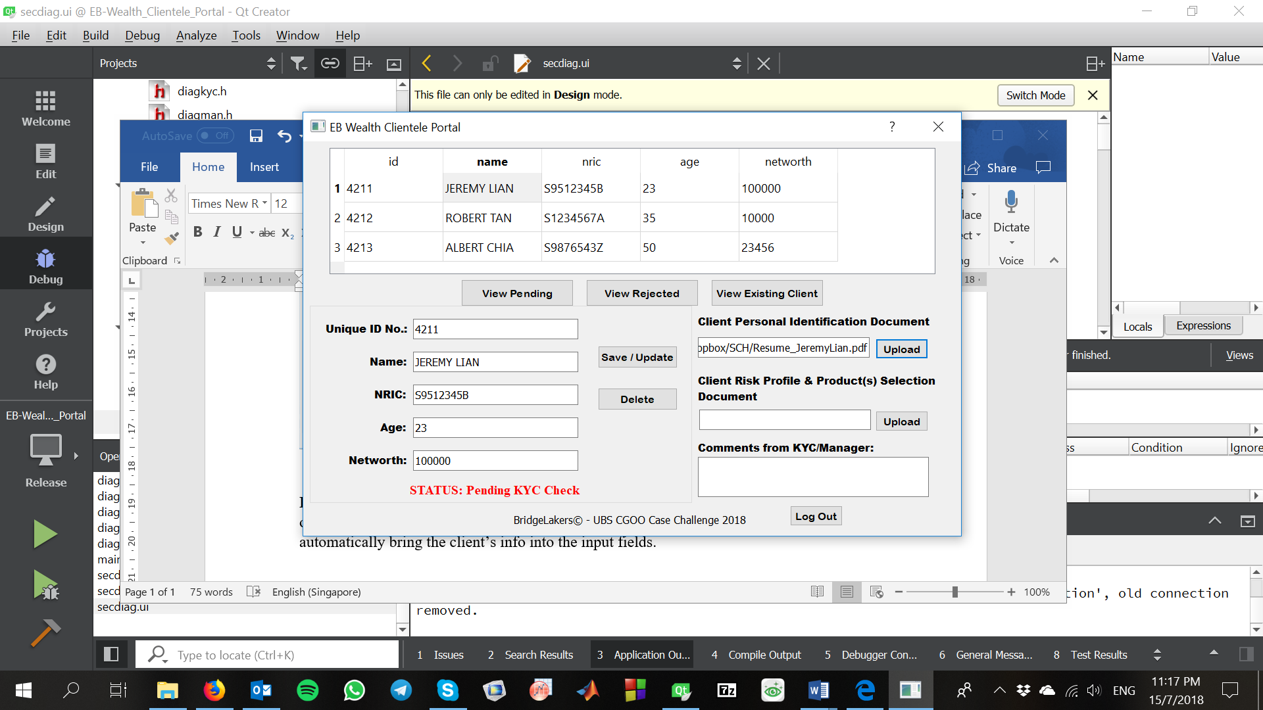

Figure 2. CA screen.

Example of a CA screen. Double click on input fields to enter data, including the uploading of PDF documents in the 2 UPLOAD fields. Values in table can be doubled clicked on to automatically bring the client’s info into the input fields.

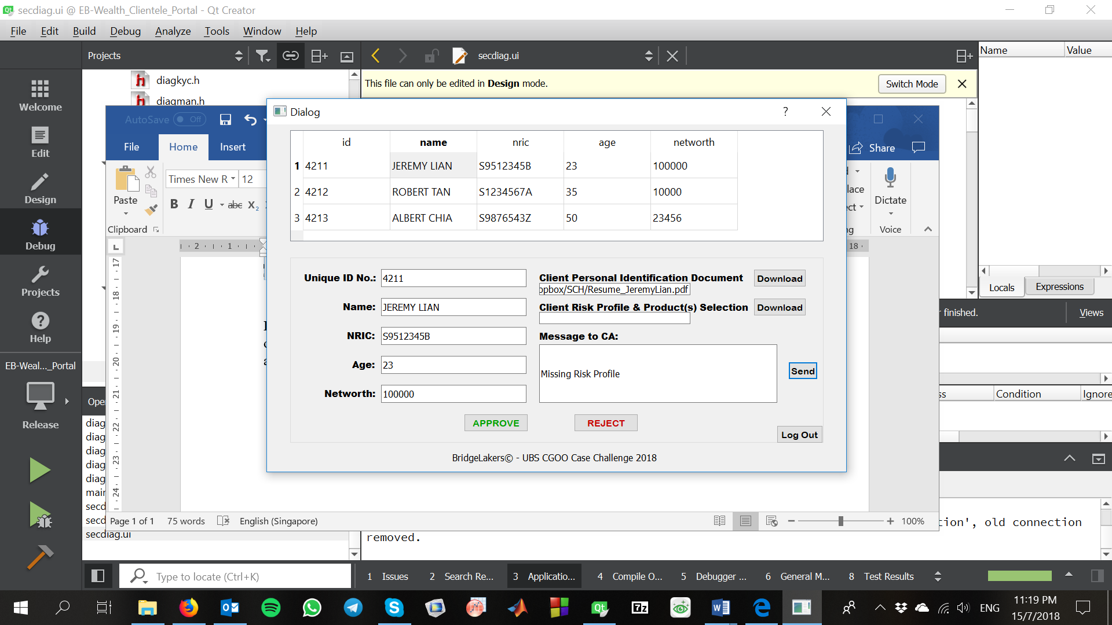

Figure 3. KYC screen.

Example of KYC screen. KYC can only see profiles pending approvals. Double click on table values to bring up client’s data into output fields, including the download fields. In this example, the Risk Profile PDF document is missing and the KYC can send a message to CA to inform him/her.

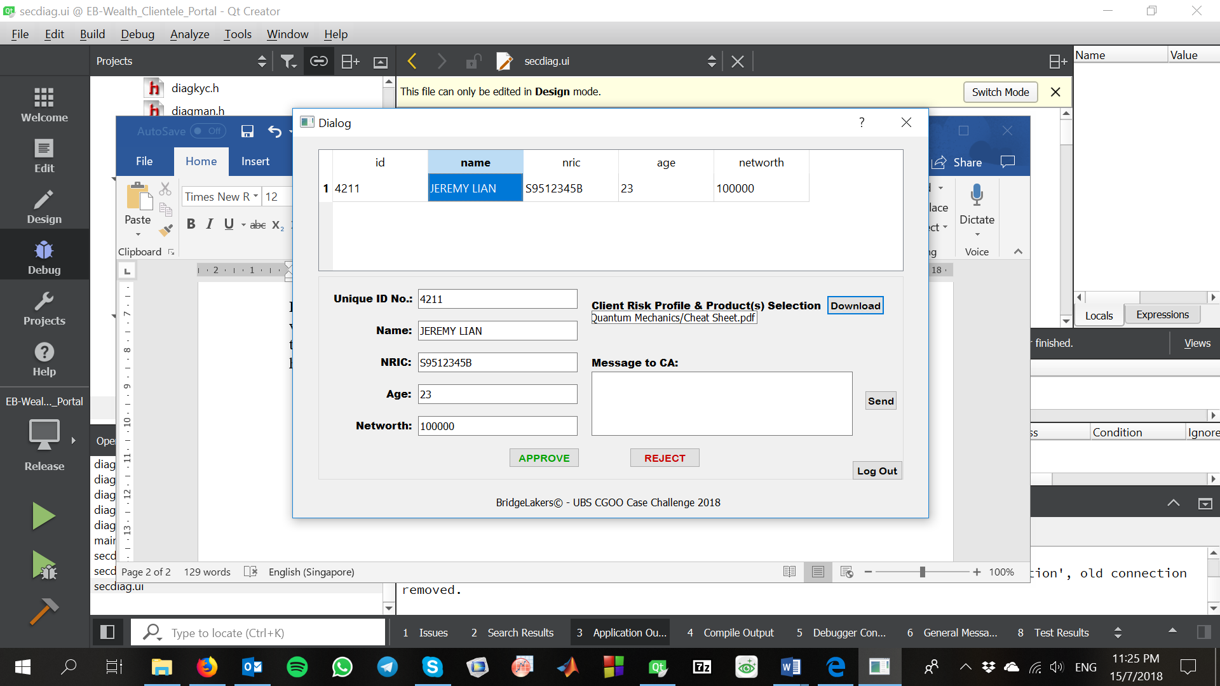

Figure 4. Manager screen.

Example of Manager screen. Manager can only see profiles pending approved by KYC. Double click on table values to bring up client’s data into output fields, including the download fields. In this example, the Risk Profile PDF document can be downloaded to user selected destinations for perusal.

**Download link for EB Wealth Management Clientele Portal Prototype 1.0:**

<https://www.dropbox.com/sh/jh2ve73h7k21ise/AAB7vzS07z4c5x6UZm6SL0Q5a?dl=0>